

**UNIVERSITY OF PETROLEUM & ENERGY STUDIES**

**Dehradun**

**CONTINOUS INTEGRATION**

**AND**

**CONTINOUS DELIVERY**

**Name: Shivani Tyagi**

**Course: B. TECH CSE DevOps (2018-22)**

**Roll no.: R171218097**

**Sapid: 500067253**

**Experiment-13**

**Deploy First Docker Container**

Run following commands to deploy your first docker container

1. Docker Images

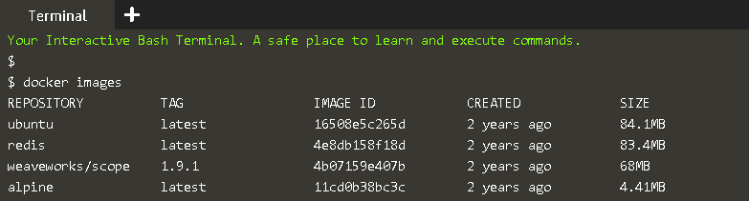

1. Docker Search

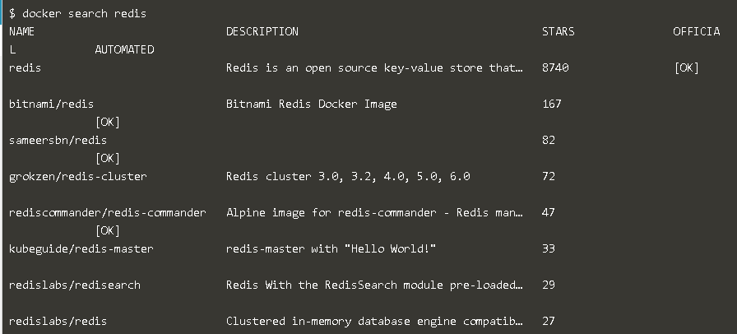

1. Docker pull

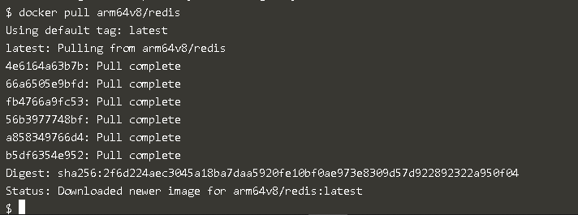

1. Docker Run (-d, -it, -p, --name)

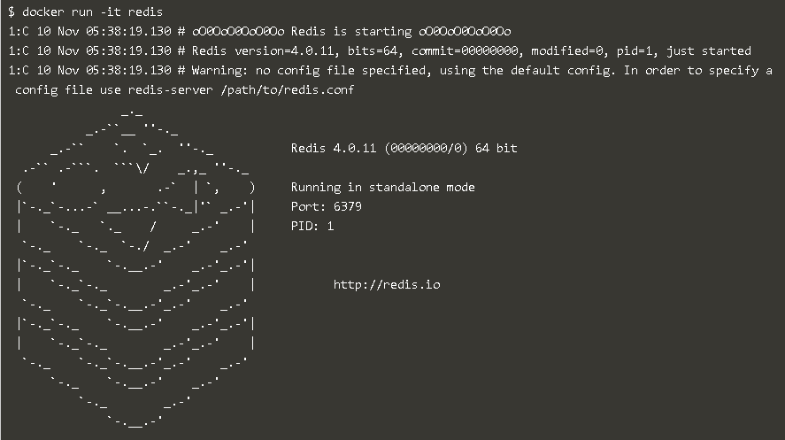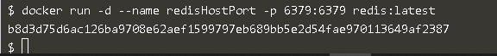

1. Docker ps

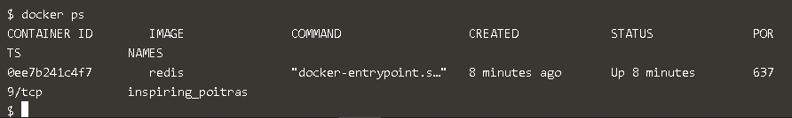

1. Docker ps –a

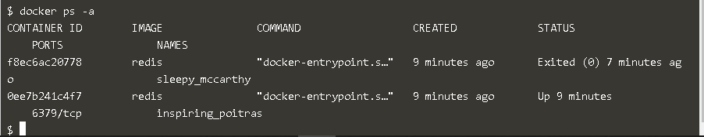

1. Docker inspect

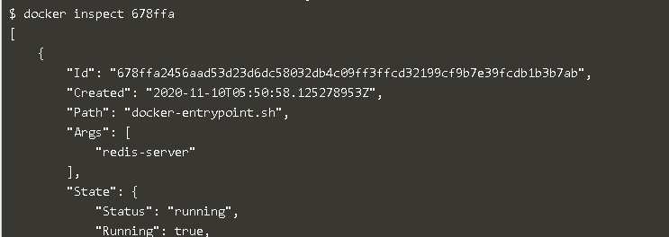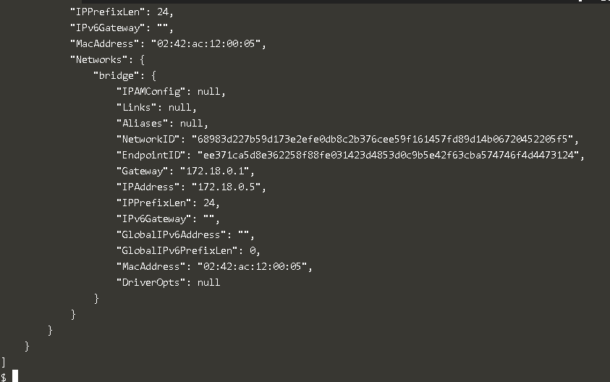

1. Docker stop

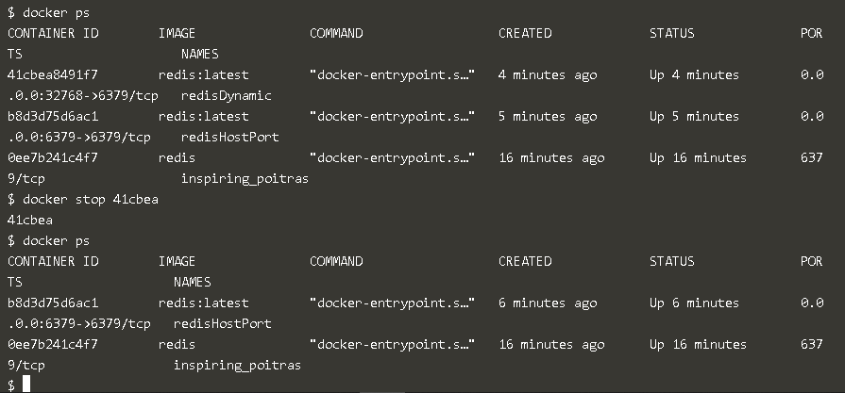

1. Docker start

